Ivan Cruz

Prof. Waziri

IT-520

April 10, 2018

Lab 7

1. The most prevalent SSID was 30 Munroe St while linksys12 was the second. 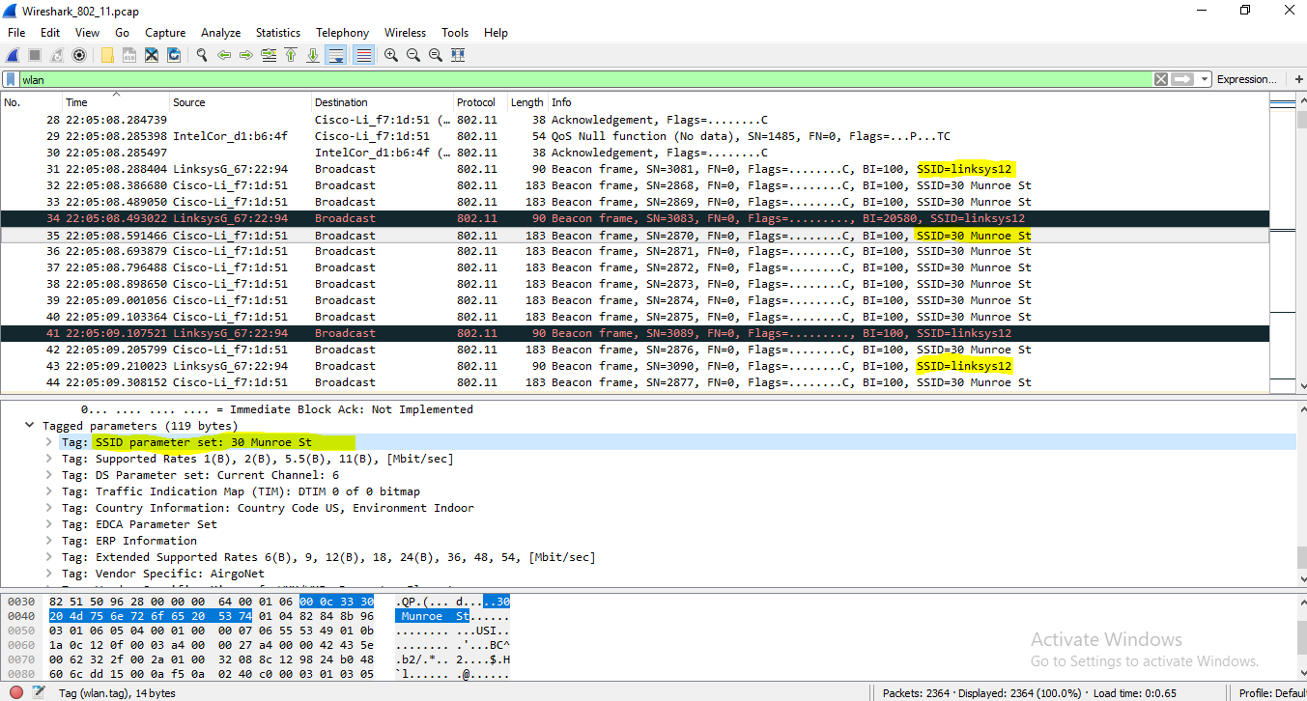
2. The time interval of the beacon frames between linksys_ses-24086 and 30 Munroe St. is 0.1024 seconds 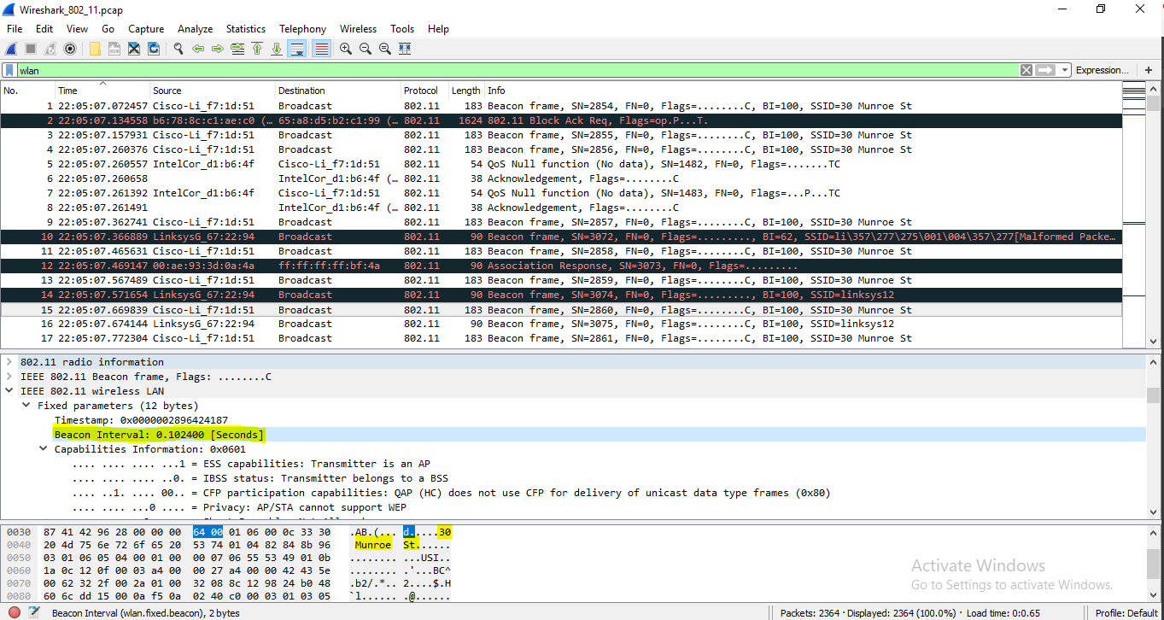
3. The MAC address of 30 Munroe St. is 00:16:b6:f7:1d:51.

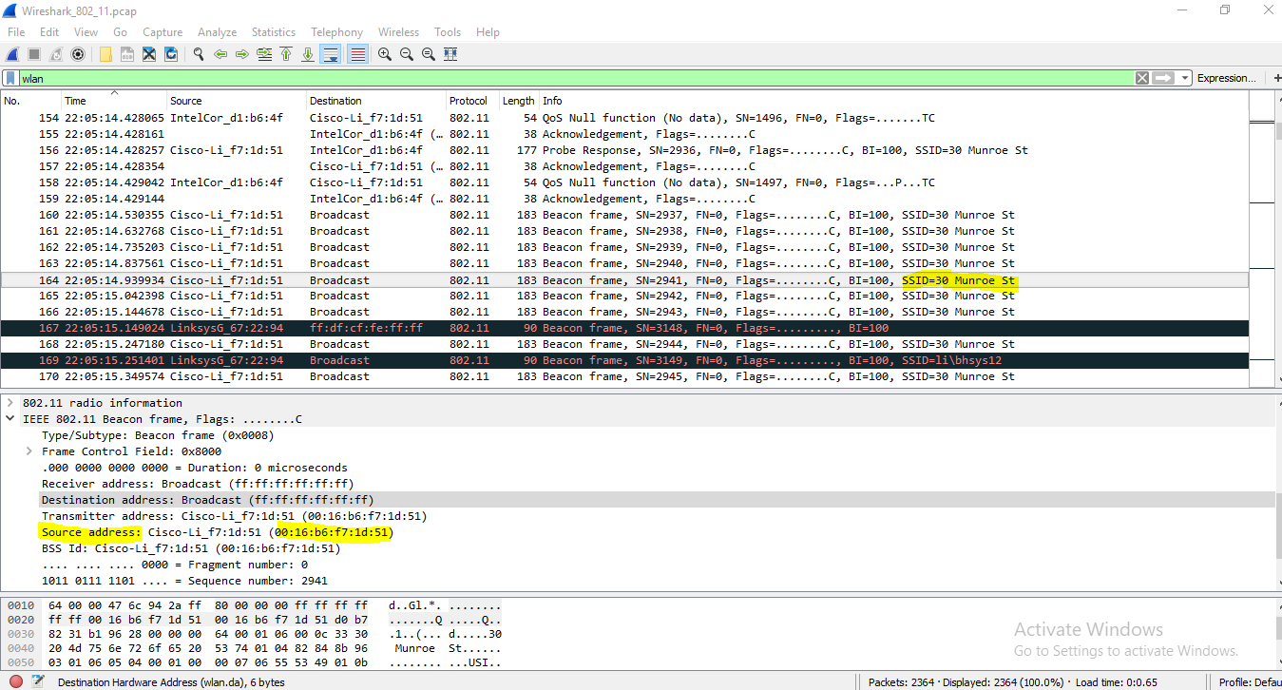

1. Since the this is a beacon frame, a broadcast of the entire WLAN is the destination; resulting in a default MAC address of ff:ff:ff:ff:ff:ff. 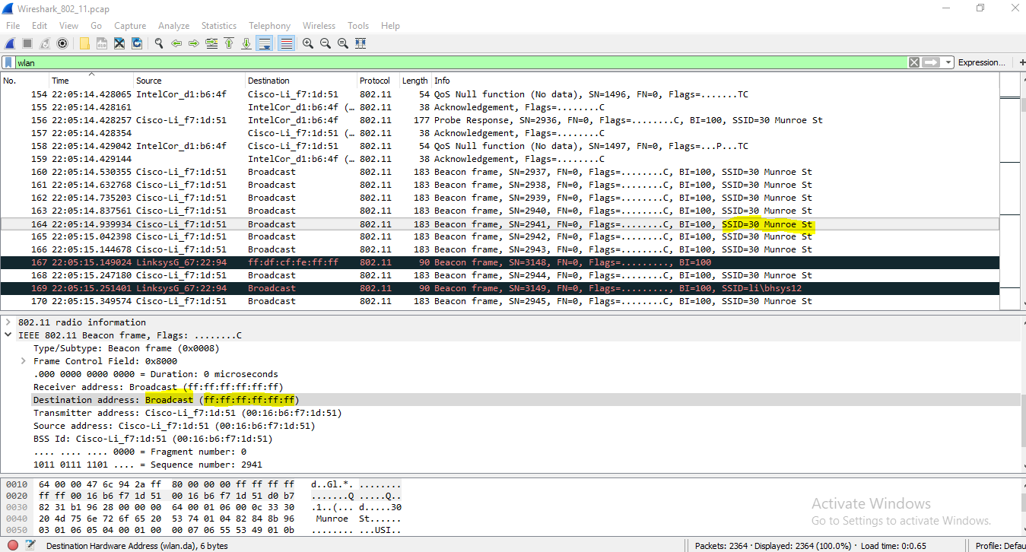
2. The MAC BSS id of 30 Munroe St. is 00:16:b6:f7:1d:51

